The positive duty
Checklist for employers
Under the Sex Discrimination Act, organisations and businesses have a positive duty to eliminate discrimination, sexual harassment and victimisation in the workplace. Commencing on 12 December 2023, the Australian Human Rights Commission (AHRC) has new powers to investigate and enforce compliance with the positive duty. Optometry Victoria South Australia has put together the following checklist to ensure that you and your practice are ready. It is designed to be read in conjunction with the positive duty information pack.
The checklist will help you to navigate the AHRC’s resources and ensure that your practice is not only compliant with the updated legislation but is a safe and respectful workplace that is prepared to handle discrimination, sexual harassment and victimisation should it occur.
The checklist breaks down actions you must take to prepare for the changes in legislation into subcategories, informed by the AHRC’s seven standards of the positive duty.

- Leadership
  - Do you understand your new obligations as an employer under the Sex Discrimination Act?
  - Do you have in place a Sexual Harassment Prevention & Response Plan? (Template provided, page 3).

- Culture
  - Review and reflect on the attached Gender Equality Framework (page 6).

- Knowledge
  - Define and prohibit sexual harassment and sex-based discrimination in your Code of Conduct or Appropriate/Respectful Workplace Behaviour Policy.
  - Do you refer to this code/policy in staff contracts, induction and training?

- Risk Management
  - Have you identified the risks present regarding unlawful conduct in your workplace, and taken steps to manage these risks? (Risk Register template provided, page 8)

- Support
  - Inform your employees about available support if they experience or witness an incident of relevant unlawful conduct.
  - Display the provided WorkSafe Victoria or SafeWork Australia posters about sexual harassment in staff common areas.

- Reporting/Response
  - Create a reporting plan if your staff experience or witness an incident of relevant unlawful conduct (Immediate Response Plan template provided, page 13) and communicate it to staff.

- Evaluate
  - Include questions about employees’ experience of relevant unlawful conduct in the workplace in regular staff surveys.
  - Set a date in the next year to review these policies.

INDEX

Positive Duty Checklist……………………………………………………….1

Sexual Harassment Prevention & Response Plan Template……………..3

Gender Equality Framework…………………………………………………6
Resource created by Victorian Equal Opportunity and Human Rights Commission

Risk Register Template……………………………………………………….8

Sexual Harassment Posters…………………………………………….….10
Resources created by WorkSafe Victoria and Safe Work Australia

Immediate Response Plan Template………………………………………13
Resource from the Respect@Work website, created by the Australian Human Rights Commission and the Respect@Work Council

Further staff support resources…….………………………………………14
Courtesy of WorkSafe Victoria and SafeWork SA

Sexual Harassment Prevention & Response Plan
Template

- RELATED POLICY
  - Outline below the existing relevant policies your practice may already have in place, such as:
    - Employee Code of Conduct – if you have an extensive code of conduct, you may insert the relevant tenets into this Prevention & Response Plan under a section titled “PRINCIPLES”.
    - Appropriate Workplace Behaviour Policy (see SafeWork SA Bullying and Inappropriate Behaviour Policy template, page 14)
    - Complaints Handling Policy (see SafeWork SA Grievant and Complaint Resolution Procedure/Grievance and Complaint Report Form template, page 13)
  - The above code and associated policies apply to the conduct of all *insert practice name* employees, who each agree they are familiar with and bound by them. The code and associated policies also apply to any person who enters the workplace.
  - The above code and policies apply to workplaces, and after hours work and events which individuals may attend as a result of work-related duties.

- DEFINITIONS - Courtesy of the Australian Human Rights Commission
  - Sex-based discrimination - is when someone is treated unfairly, or is unreasonably disadvantaged, because of their sex, or a characteristic that is generally associated with people of their sex.
- making assumptions about the sort of work that people are capable – or not capable – of performing because of their sex
- thinking that people are suited to different kinds of work because of their sex
- having a personal preference for working with people of a particular sex
- thinking that treating people exactly the same is the best way to ensure fairness between people of different sexes.
  - Sexual Harassment - is any unwelcome conduct of a sexual nature that occurs in circumstances in which a reasonable person, aware of those circumstances, would anticipate that the person being harassed might feel offended, humiliated or intimidated.

- AWARENESS & TRAINING
  - *Insert practice name* recognises that having a policy or code is not enough, and that steps must be taken to create a robust positive culture by improving awareness, providing training and implementing robust systems and processes.
  - *Insert practice name* has a duty to ensure that all staff are aware of this Policy and expectations regarding sexual harassment.
  - All members of staff at *Insert practice name* are expected to actively role model the outlined expected behaviors through ongoing dialogue, active participation in education, and reinforcement of *Insert practice name*’s commitment to preventing and responding to workplace sexual harassment. This collective effort contributes to fostering a workplace environment that prioritizes respect, equality, and a shared responsibility to maintain a culture free from harassment.
  - *Insert practice name* recognises that it has a duty to provide adequate training to all staff.
    - Outline the training and/or resources provided to staff upon induction and throughout their employment, and how this will be tracked and documented.

- REPORTING & RESOLUTION
  - Outline here the reporting procedure for when staff members witness or experience sex-based discrimination, sexual harassment, or other relevant unlawful conduct. (See SafeWork SA Grievance and Complaint Resolution Procedure and Report Form templates, page 14).
  - Outline various informal/formal methods to resolve complaints depending on the nature and seriousness of the allegations, along with the wishes of the Complainant.

- SUPPORT
  - A staff member who alleges sexual harassment in the workplace, or a person who alleges that sexual harassment took place, should have their allegations responded to immediately with a focus on respect, confidentiality and individual wellbeing from *insert practice name*.
  - Ensuring that a Complainant is aware of available reporting options is a key part of the resolution process. This may involve referral to counselling or other independent avenues of professional advice and assistance, with the consent of the Complainant.
  - It is imperative to ascertain and respect the wishes of the Complainant with respect to privacy and confidentiality. Where criminal conduct, including sexual assault, has occurred, or may have occurred, referral to police should only occur subject to the consent of the Complainant.

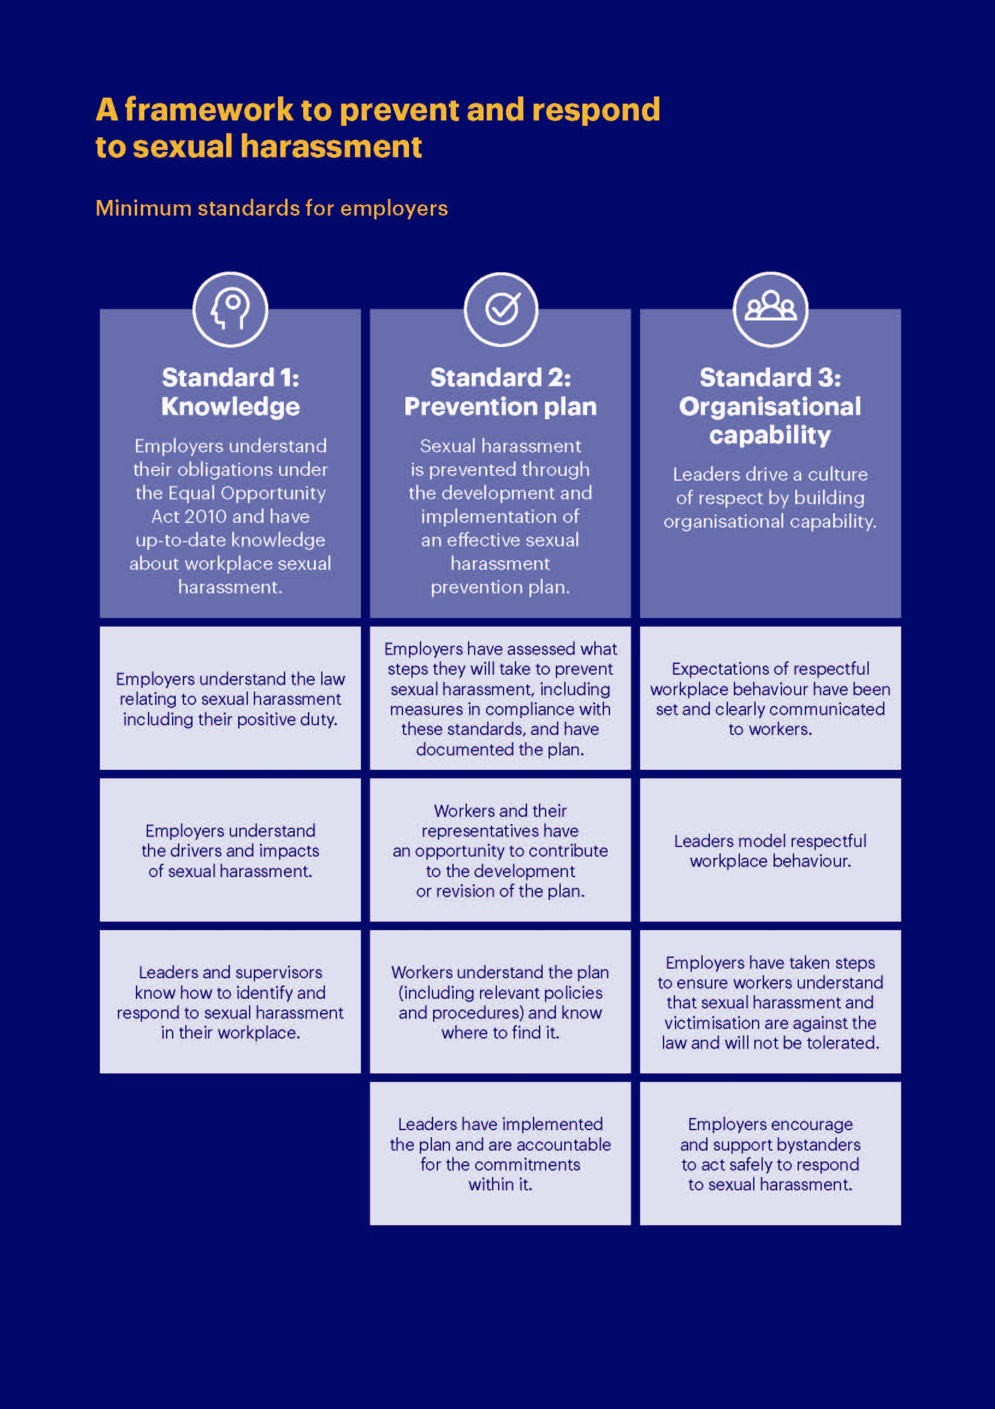

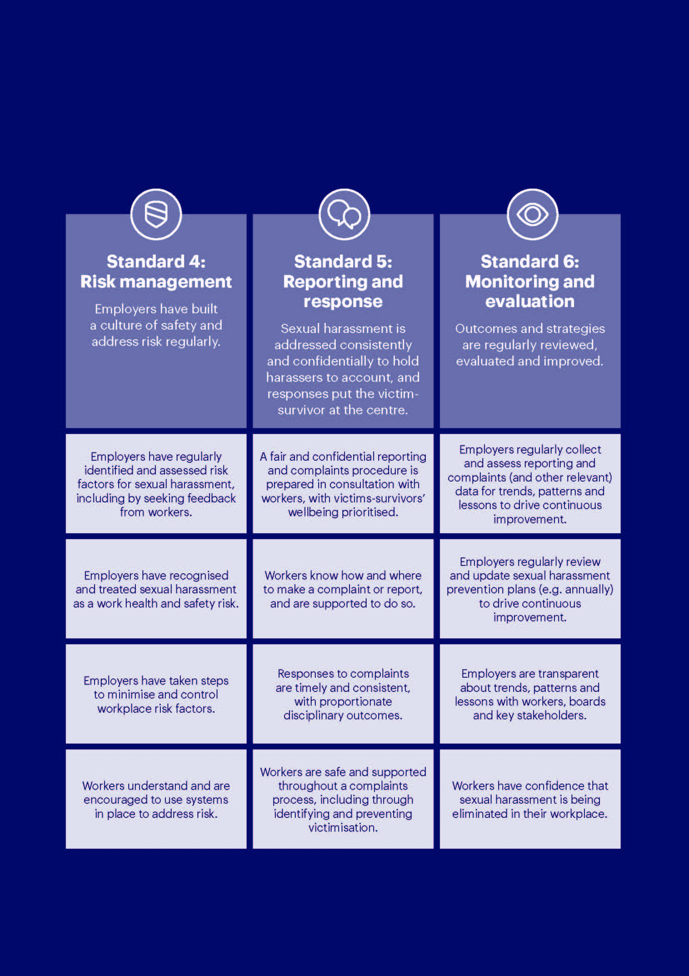

Sexual Harassment Positive Duty: Risk assessment template

Practice name: Assessment carried out by:

Date of next review: Date assessment was carried out:

What are the hazards? | Who might be harmed and how? | What are you already doing to control the risks? | Likelihood  Rare, Unlikely, Possible, Likely, Almost Certain | Consequence  Negligible, Minor, Moderate, Major, Catastrophic | Risk Rating  *See Matrix | What further action do you need to take to control the risks? | Who needs to carry out the action? | When is the action needed by? | Done  (Date)

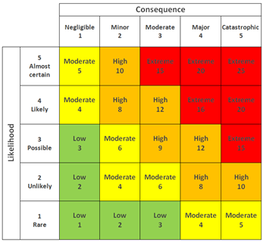

Risk Rating Matrix
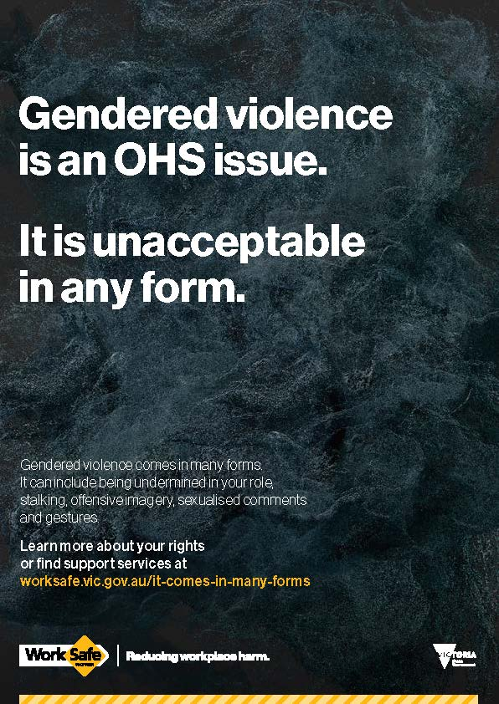

Download PDF here
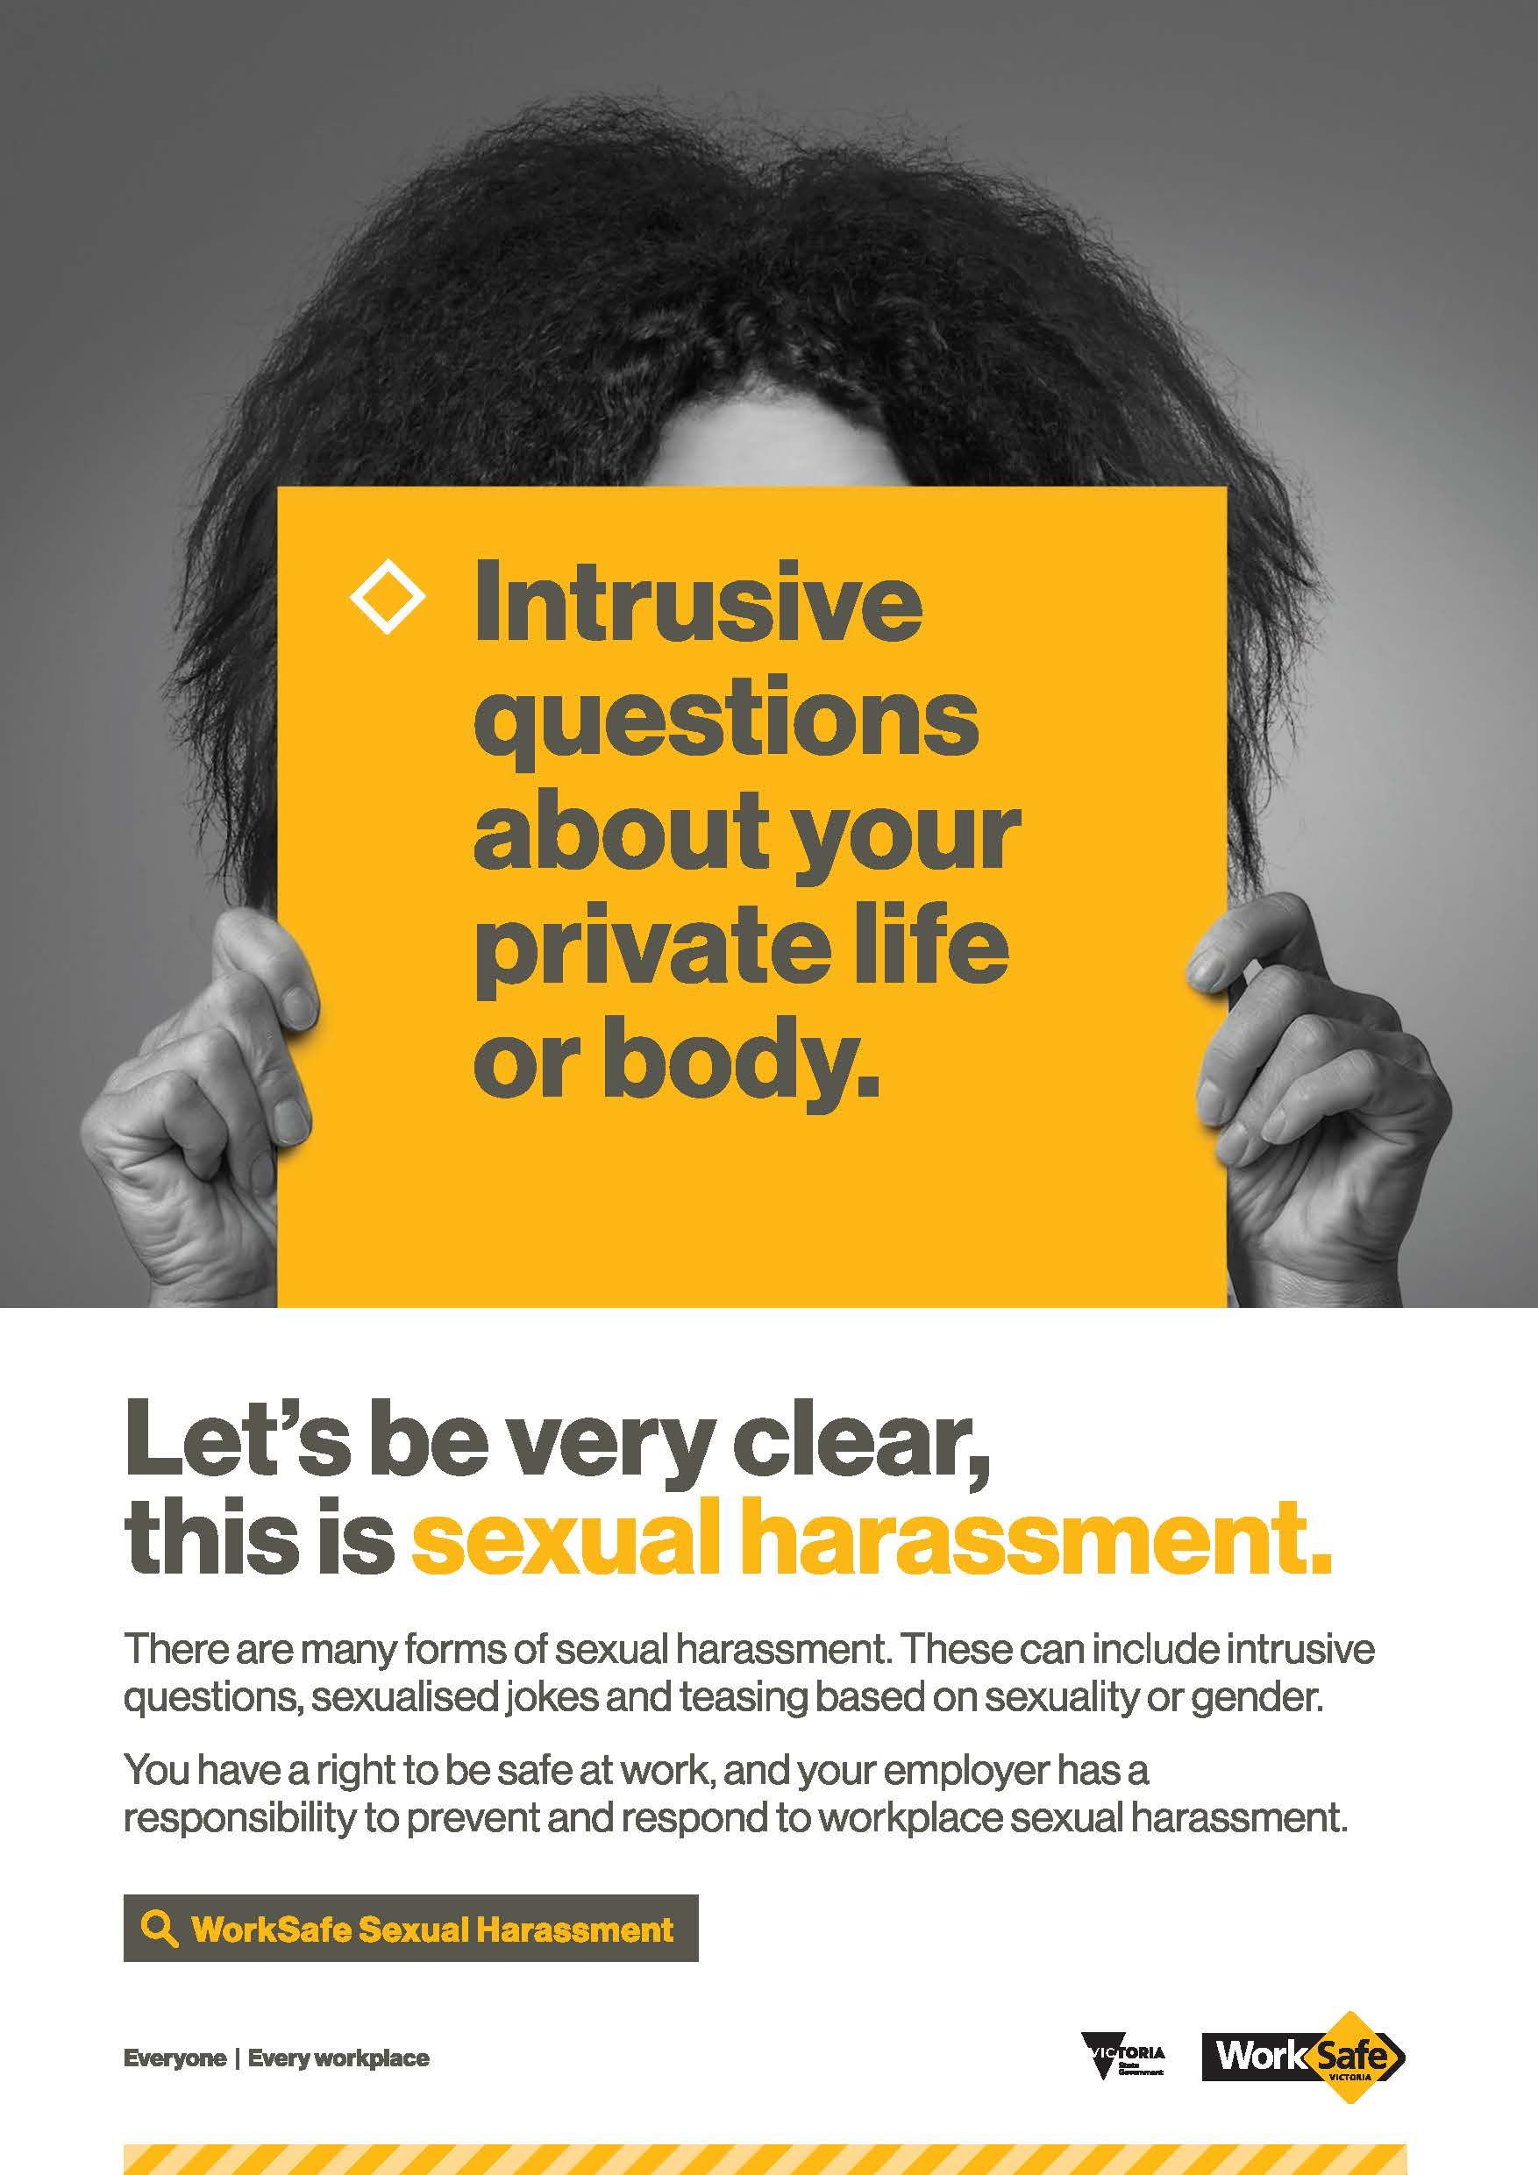

Download PDF here

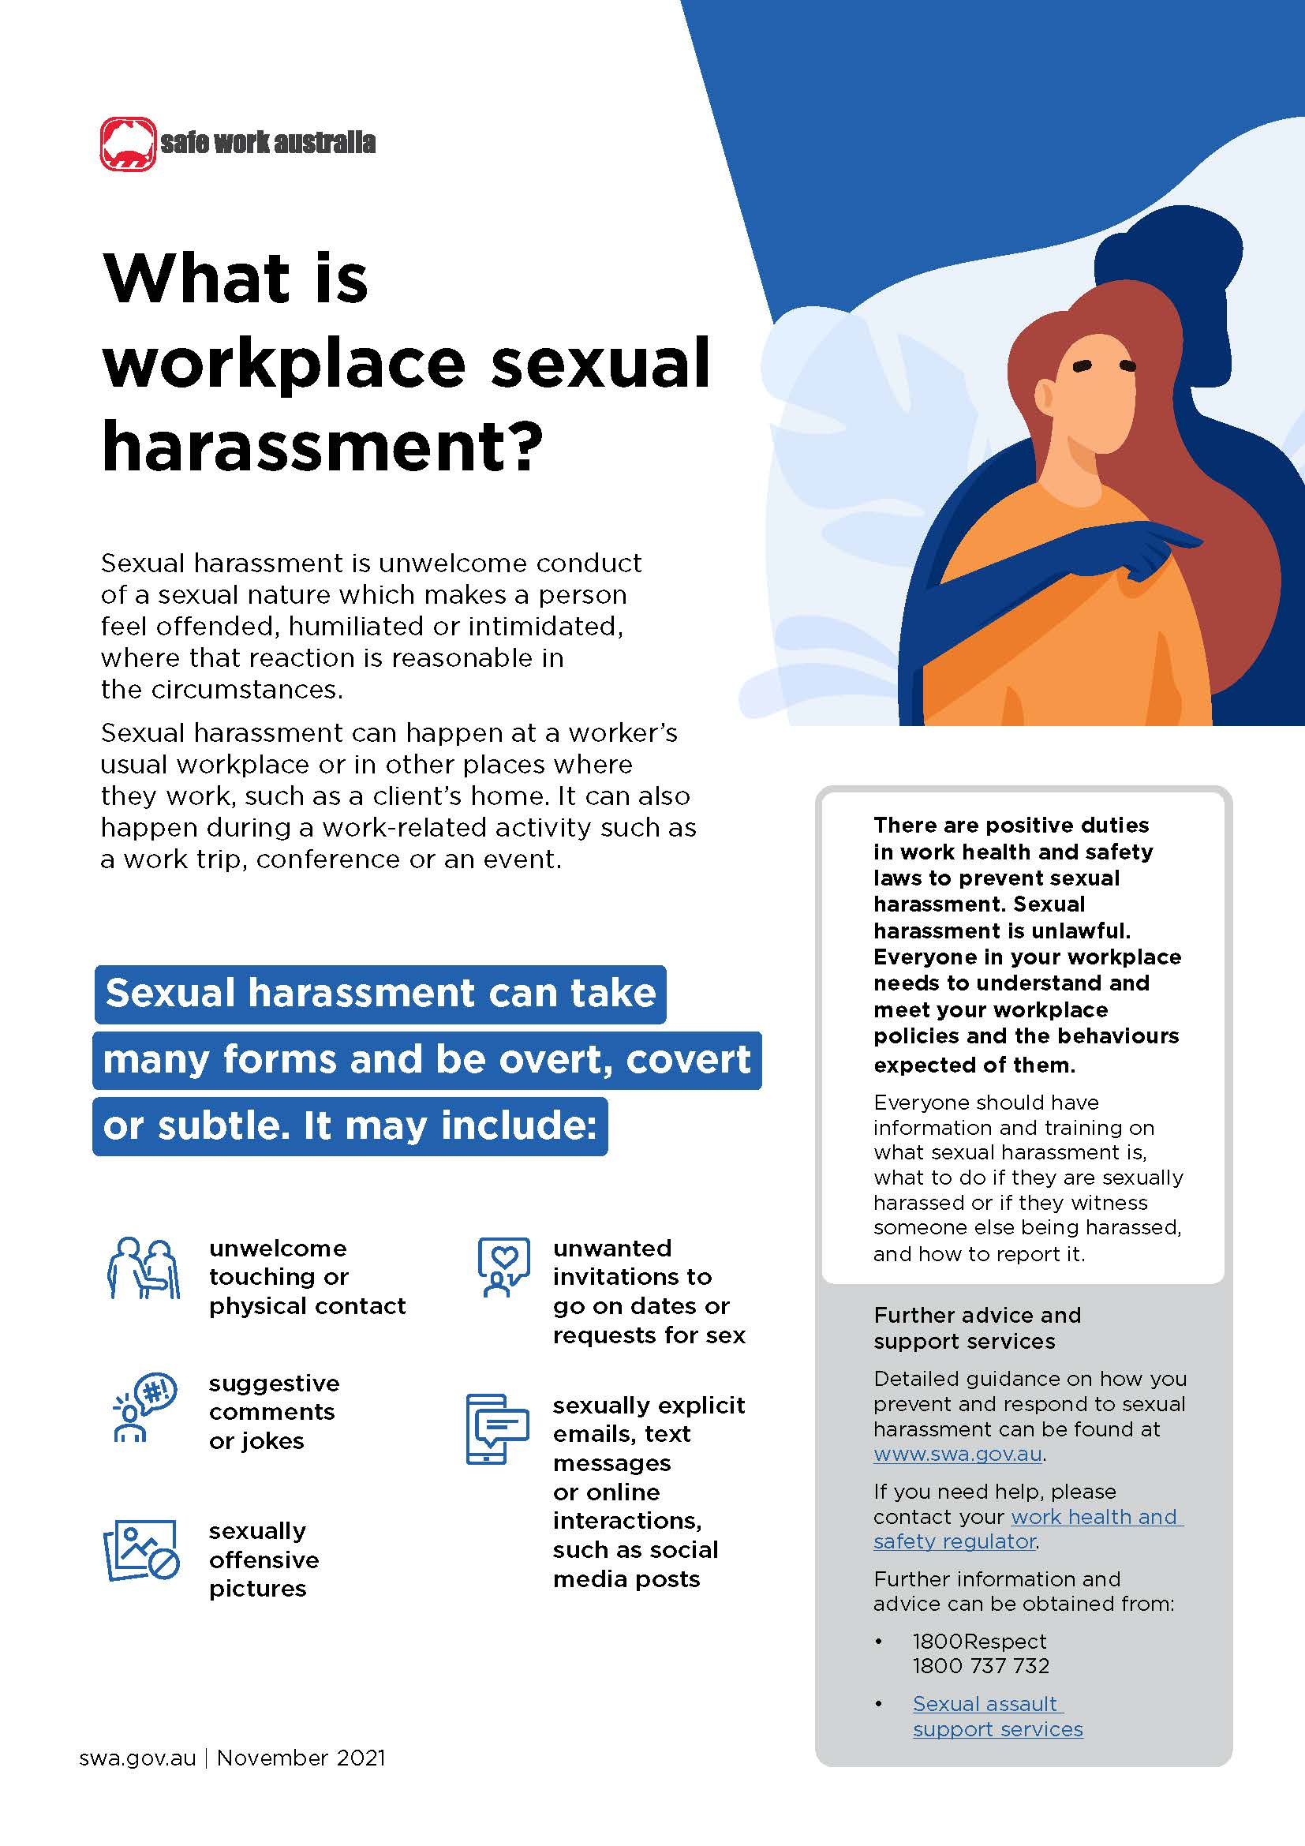

Download PDF here
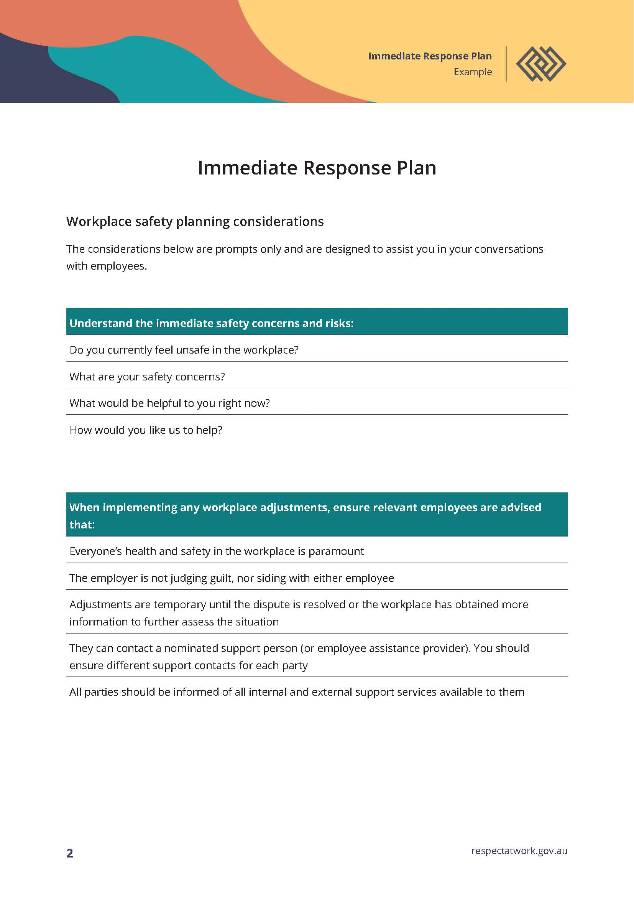

Download complete Immediate Response template here

Further Staff Support Resources

South Australia

WorkSafe SA Templates:
- Bullying and Inappropriate Behaviour Policy – Download here
- Grievance and Complaint Resolution Procedure – Download here
- Grievance and Complaint Report Form – Download here

For further information on reporting sexual harassment and support available in SA, visit this website.

Victoria

For further information on reporting sexual harassment and support available in VIC, visit this website.
If you have experienced sexual harassment in the workplace you have a range of options and support services available to report the incident:
- Your manager or human resources department
- WorkSafe advisory service or phone 1800 136 089 (open 7.30am – 6.30pm Monday to Friday)
- Victorian Equal Opportunity and Human Rights Commission or phone 1300 292 153
- VEOHRC anonymous reporting chat tool
- Victoria Police – you can contact your local police station

BOTH STATES
Fair Work Ombudsman on 13 13 94
Fair Work Commission or phone 1300 799 675

